

Logical And Arithmetic Calculator

**Team Members**

**Under supervision**

Abdelrahman Shrief Ali 20200116

Sondos Reda Abdelmoaty 20200004

Mohamed Alaa Mohamed 20200233

Ali Osama Ebied 20200131

Khloud Osama Elhwary 20200184

Dr. Ayman mohamed

Eng / Aya Shrief

# **Table of Contents**

**Page no.**

1. **Introduction** 3
2. **Component List** 4
   1. Atmega 32 4
   2. Character Lcd 16*2 7
   3. Keypad 4*4 9
   4. 7448 Decoder 11
   5. 7-segment Display 13
   6. 9v dc Battery 15
3. **Project Circuit** 16
4. **Project Code** 17
5. **References** 21

# **Introduction**

Logical And Arithmetic Calculator is a fascinating project that demonstrates the power of technology to create innovative and interactive experiences.

This project offers diverse functionalities, encompassing a brain-testing suite, calculator, and converter. Leveraging a user-friendly interface driven by a keypad and LCD display, it facilitates seamless interaction and exploration of logical, arithmetic, and data manipulation operations.

Notably, the code integrates intricate algorithms, harnessing the power of C programming, to ensure optimal functionality. With meticulous attention to detail, each module within this codebase contributes to a holistic understanding of embedded systems.

These abstract invites enthusiasts and learner to delve into an immersive experience, where the amalgamation of precision and functionality defines the essence of embedded programming. Join us on this journey to unlock the potential and intricacies of embedded systems through this thoughtfully engineered project.

# **Component List**

|  |  |
| --- | --- |
| Atmega 32 | Buzzer |
| Lcd 16*2 | Push buttons |
| Keypad | 9v Battery |
| 7448 IC | Cathode 7-Segmant |

* 1. **Atmega 32**

The ATmega32 is a popular 8-bit microcontroller from the Atmel AVR family. Here's a summary of its key features :

**Features**

1. **Architecture:** It's based on the Harvard architecture with a RISC (Reduced Instruction Set Computing) core. Operating at speeds up to 16 MHz, it offers high performance in embedded applications.
2. **Memory:** ATmega32 has 32 KB of Flash memory for program storage, 2 KB of SRAM for data storage, and 1 KB of EEPROM for non-volatile data storage. Its Flash memory is reprogrammable, enabling easy updates of the program.
3. **GPIO:** Equipped with a range of General-Purpose Input/Output pins, it provides flexibility for connecting to external components and devices.
4. **Peripherals:** It features a rich set of peripherals including timers/counters, UART (Universal Asynchronous Receiver-Transmitter), SPI (Serial Peripheral Interface), I2C (Inter-Integrated Circuit), ADC (Analog-to-Digital Converter), and PWM (Pulse Width Modulation) modules, allowing versatile interfacing with various external devices.
5. **Power Management:** The controller offers multiple power-saving modes, optimizing power consumption in battery-operated applications.
6. **Development Environment:** Programming the ATmega32 is typically done using C/C++ with the AVR-GCC compiler and Atmel Studio IDE, providing an efficient and robust development environment.
7. **Applications:** Due to its versatility and robustness, the ATmega32 finds applications in various domains such as consumer electronics, industrial automation, robotics, IoT (Internet of Things), and more.

**Programming** :

**A**rduino Uno can be programmed using the Atmel Studio Integrated Development Environment (IDE), which is a free software tool that allows users to write and upload code to the board. The IDE uses C programming language.

**Usage :**

It is used for controlling and interfacing with Lcd display , buzzer , 7segmant and decoder IC .

**Atmega32 Pinout:**

* 1. **Lcd 16*2**

A 16x2 LCD (Liquid Crystal Display) is a commonly used alphanumeric display module consisting of 16 columns and 2 rows, hence the designation "16x2". Each character cell in the display typically holds a 5x8 or 5x10 dot matrix character, allowing for the display of 16 characters per line across 2 lines.

Here are some key features and aspects of a 16x2 LCD:

* 1. **Character Display**: It can display alphanumeric characters, symbols, and some custom characters in a 16-character wide and 2-line format.
  2. **Dot Matrix**: Each character cell in the display is made up of a matrix of dots, usually 5x8 or 5x10, allowing for the representation of different characters.
  3. **Interface**: It usually interfaces with microcontrollers or other devices using parallel or serial communication protocols. Parallel interfacing uses multiple data lines for control and data transfer, while serial interfacing (like I2C or SPI) uses fewer pins but requires additional components.
  4. **Controller**: Typically, it contains an embedded controller (such as the Hitachi HD44780 or compatible controllers) that handles the display operation and data management.
  5. **Backlight**: Many 16x2 LCDs come with an optional backlight, usually in the form of an LED, to enhance visibility in low-light conditions.
  6. **Applications**: They are extensively used in various applications such as small embedded systems, DIY electronics, appliances, industrial equipment, and educational projects.

**LCD 16*2 Pinout:**

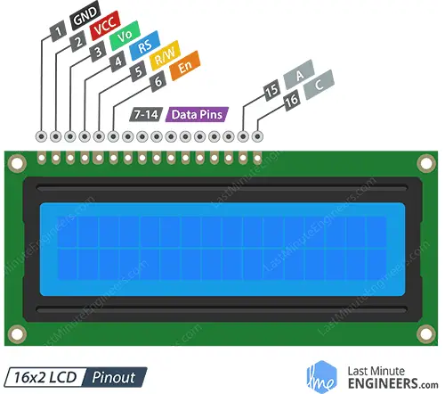

* 1. **Keypad 4*4**

A 4x4 keypad is a common input device consisting of a matrix of 16 keys arranged in a grid format, typically with 4 rows and 4 columns, hence the designation "4x4". Each key press generates a unique signal corresponding to a row and a column intersection in the matrix.

Key components of a 4x4 keypad:

* 1. **Matrix Configuration**: The keypad has rows and columns forming a grid layout. When a key is pressed, it creates a connection between a specific row and column, enabling identification of the pressed key.
  2. **Interfacing**: It's often interfaced with a microcontroller or other control circuits. The microcontroller scans the rows and columns to detect a key press and determines which key was pressed based on the intersection of the row and column.
  3. **Wiring**: Each key is uniquely identified by the row and column it is connected to. The wiring configuration enables the microcontroller to read these intersections to detect key presses.
  4. **Applications**: 4x4 keypads are commonly used in various electronic systems, such as security systems, access control panels, industrial control systems, electronic locks, digital input interfaces for microcontrollers, and more. They offer a simple and cost-effective way to input data into electronic devices.

Each key on the keypad generates a unique code or signal, making it a convenient input interface for controlling or interacting with electronic systems. The matrix structure of the keypad allows for multiple keys to be integrated into a relatively small space, making it a popular choice for a wide range of applications.

**Keypad 4*4 Pinout:**

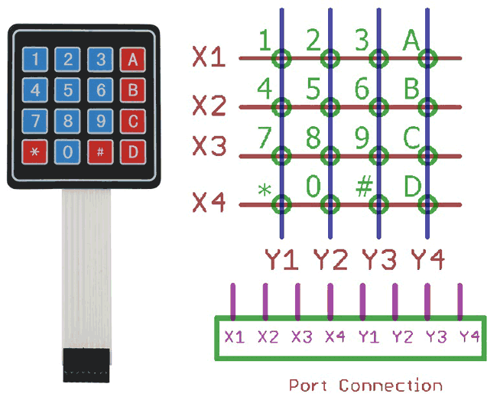

* 1. **7448 IC**

The 7448 is a BCD-to-7-segment decoder/driver IC (Integrated Circuit). It's designed to convert Binary Coded Decimal (BCD) input into signals capable of driving a 7-segment display. Here's a breakdown of its functionalities:

* **BCD Input**: The 7448 takes Binary Coded Decimal (BCD) input, which is a four-bit binary representation of decimal digits (0-9). Each BCD input represents a decimal digit.
* **7-Segment Display Driver**: It converts the BCD input into signals that drive a 7-segment display. A 7-segment display is a display device that can show numerical digits (0-9) and sometimes additional characters (such as A-F for hexadecimal displays) using seven segments arranged in a specific pattern.
* **Output Signals**: The outputs of the 7448 correspond to the segments of a 7-segment display (a-g), and the IC provides appropriate signals to illuminate the segments that form the desired digit according to the BCD input.
* **Enable and Blanking Pins**: The 7448 typically has additional pins for enabling specific segments or entire displays and for blanking the display when needed.
* **Applications**: It's commonly used in digital systems, electronic displays (like digital clocks, calculators, scoreboards, etc.), and wherever there's a need to drive a 7-segment display based on BCD input.

The 7448 IC, along with other similar ICs like the 7447 (which does not have active-high outputs), simplifies the task of driving 7-segment displays in digital circuits by handling the conversion from binary to the specific patterns required for each digit to be displayed.

**7448 IC Pinout:**

* 1. **7-Segmant Display**

A 7-segment display is a visual display component that's commonly used to represent numbers, letters, and some special characters. The "cathode" version refers to the type of 7-segment display where the individual LED segments share a common cathode (-) connection.

Here's a breakdown:

* **7 Segments**: The display comprises seven individual LED segments arranged in a specific pattern to represent digits from 0 to 9 and sometimes letters A to F (for hexadecimal display).
* **Segment Configuration**: Each of the seven segments is labeled from 'a' to 'g', representing different parts of the digit. When these segments are illuminated in various combinations, they can display different numbers or characters.
* **Common Cathode**: In a common cathode 7-segment display, all the cathodes of the LED segments (the negative terminals) are connected as a common pin. Each LED segment's anode (+) is controlled independently to illuminate that segment.
* **Operation**: To light up a particular segment, a voltage is applied between the common cathode and the specific anode of the segment. When a segment's anode is given a positive voltage relative to the common cathode, current flows through that segment, and it emits light, creating the desired display pattern.
* **Usage**: These displays are commonly used in various applications where numerical or limited character representation is needed, such as digital clocks, timers, digital meters, and simple numeric indicators.

The common cathode 7-segment display requires separate control signals to illuminate each segment selectively to display the desired number or character.

**7-Segmant Display Pinout:**

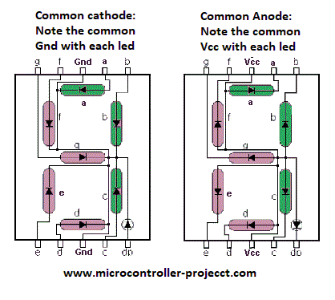

* 1. **9V dc Battery**

A 9V battery is a type of dry cell battery commonly used in small electronic devices such as smoke detectors, remote controls, and guitar pedals. It is a rectangular-shaped battery with a voltage of 9 volts and a capacity of around 500mAh to 1200mAh depending on the brand and type of battery.

The battery is made up of six small 1.5V cells connected in series, which gives it a total voltage of 9V. The battery terminals are typically a snap connector or a screw terminal, and the battery itself is usually encased in a plastic shell.

It is important to note that 9V batteries have a relatively high internal resistance, which means that they are not suitable for high-current applications. They are best suited for low-power devices that require a steady, long-lasting power source.

**9V dc Battery Image :**

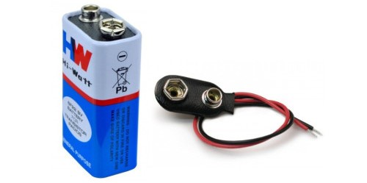

# **Project Circuit**

# **Project Code**

Due to the length of the code, we uploaded it to GitHub which is found in the next link :

<https://github.com/abdo-shrief270/Embedded_Final_project>

# **References**

* *google.com*
* *ampere-electronics.com*
* *lastminuteengineers.com*